**A PROJECT REPORT**

**ON**

**“QUIZ GAME”**

SUBMITTED IN PARTIAL FULFILLMENT OF THE REQUIREMENTS FOR THE AWARD OF

**DIPLOMA IN**

COMPUTER SCIENCE AND TECHNOLOGY

**SUBMITTED TO**

**WEST BENGAL STATE COUNCIL OF TECHNICAL EDUCATION**

**SUBMITTED BY**

Name of the student's Registration number

1. RONIT KUMAR ROY D202111688
2. ABDUL MUKSIT D202111654
3. NUR BADSA SK D202111679
4. DIBYENDU DAS D202111665
5. ISHIKA KARMAKAR D202111668



**KALIACHAK GOVERNMENT POLYTECHNIC, KALIACHAK, MALDA**

**CERTIFICATE**

**This is to certify that the project report entitled "QUIZ GAME" Was completed by a Student of the Sixth semester Diploma in Computer Science and Technology**

1. Ronit Kumar Roy
2. Abdul Muksit
3. Nur Badsa Sk
4. Dibyendu Das
5. Ishika Karmakar

**In partial fulfillment of the requirements for the award of the Diploma** **in Computer Science & Technology and submitted to the Computer Science & Technology of Kaliachak Government Polytechnic. This work was carried out during a period for the academic year 2022-2023 as per the curriculum.**

**Name of the Guide Name of HOD**

**ASHIF SHEIKH SATTWIK BHATTACHARYA**

External Examiner Principal

**ACKNOWLEDGMENT**

This project is done as a semester project, as a part course titled “COMPUTER SCIENCE AND TECHNOLOGY”.

We are thankful for our course the principal **Kanchan Sengupta** and the HOD Sattwik Bhattacharya, Computer Science and Technology, Kaliachak Government Polytechnic, we also thank Sattwik Bhattacharya for giving us this opportunity to explore the real world and realize the interrelation without which a Project can never progress. In our present project, we have chosen the topic- "QUIZ GAME”.

We are also thankful to parents, friends, and all staff of the Computer Science and Technology department, for providing us with relevant information and necessary clarifications, and great support.

**ABSTRACT**

“Quiz Game” is a game or application that provides us with various general quiz questions and answers in a fun and interactive way.

We built this project using the programming language Python. Python is a very popular and simple programming language.

As the years pass by more and more content is added to the books. But most times students find it very difficult to understand each topic and it is hard to remember small details and topics. It is important to have an interactive and fun way of learning something, so that’s why our project is so important.

First, we did a little research that what could be the most fun way of learning something. Then we found quiz games. So, then we implemented our quiz application using the Python programming language.

And at the end, we finally got a game that included multiple questions and some options. Play the game go through a question and try to find the answers.

The meaning of making this project is to ensure that students don’t get demotivated and hopeless as if they can’t remember some topic or detail.

TABLE OF CONTENT

|  |  |  |
| --- | --- | --- |
| **SL.NO** | **CONTENT** | **PAGE** |
| 1. | TITLE PAGE | 01 |
| 2. | CERTIFICATE | 02 |
| 3. | ACKNOWLEDGMENT | 03 |
| 4. | ABSTRACT | 04 |
| 5. | INTRODUCTION | 07 |
| 6. | DEVELOPMENT TOOLS & FEATURES | 08 |
| 7. | SOURCE CODE | 09 - 18 |
| 8. | SNAPSHOTS | 19-20 |
| 9. | CONCLUSION | 21 |

**LIST OF FIGURES**

Figure 1....................................................... 15

Figure 2....................................................... 15

Figure 3....................................................... 16

Figure 4....................................................... 16

**INTRODUCTION**

These days, reading books is not enough. Students need more unique and interactive ways of learning. Possible that they will forget small but important details in many topics,

So that’s why our goal is to make an application where students not only have fun but also learn about many new things.

The first thing we did was analyze the requirements we need then design a small prototype. And by iterating the prototype model we finally reached our goal.

For now, our final product only has a single section for questions. But in the future, we defiantly add different kinds of sections to it and various new features.

The benefit of this not only helps the students but by doing research for this project, we get to know so many things and a lot of new knowledge.

**DEVELOPMENT TOOLS:**

* We use Python programming language
* Software
* Visual Studio Code.

**Features:**

1. It is free
2. It is open source

**Packages:**

1. Tkinter
2. customTkinter
3. json

**SOURCE CODE: -**

**Programming Language – Python**

# Final Project - Quiz Game using Python and json

#                                   -----------------------------Importing packages and creating the main window-----------------------------

# Importing the tkinter and custom tkinter

from tkinter import *

import customtkinter

import json

# creating the first window

win = customtkinter.CTk()

win.geometry("680x400")

win.resizable(0, 0)

win.title("Quiz Game")

customtkinter.set_appearance_mode("Dark")

customtkinter.set_default_color_theme("green")

#                                   -----------------------------All the questions-----------------------------

# get the data from the json file

with open('data.json') as f:

    data = json.load(f)

# set the question, options, and answer

Questions = (data['question'])

Options = (data['options'])

Answers = (data[ 'answer'])

#                                   -----------------------------All the important variables-----------------------------

# creating important variables

score = 0

wrong = 0

total_no_question = len(Questions)

question_no = 1

time = 11

selected_option = -1

#                                   -----------------------------All the options, result and time-----------------------------

# displaying the options and questions

def display_questions_options():

    question.configure(text=Questions[question_no-1])

    option1.configure(text=Options[question_no-1][0])

    option2.configure(text=Options[question_no-1][1])

    option3.configure(text=Options[question_no-1][2])

    option4.configure(text=Options[question_no-1][3])

#                                   -----------------------------Next Button-----------------------------

# allows next button to change the question

def next_btn():

    global score, question_no, time, wrong, selected_option

    if var1.get() == 1:

        selected_option = 1

    elif var2.get() == 1:

        selected_option = 2

    elif var3.get() == 1:

        selected_option = 3

    elif var4.get() == 1:

        selected_option = 4

    else:

        selected_option = -1

    if(Answers[question_no-1] == selected_option):

        score += 1

    elif (Answers[question_no-1] != selected_option):

        wrong += 1

    #     # print(f"nxt wrong {wrong}")

    if question_no == 1:

        enable_previous_btn()

    question_no += 1

    time = 11

    if question_no > total_no_question:

        display_result()

        next_button.configure(state="disabled")

    else:

        var1.set(0)

        var2.set(0)

        var3.set(0)

        var4.set(0)

        display_questions_options()

#                                   -----------------------------Previous Button-----------------------------

# allows previous button to change the question

def previous_btn():

    global score, question_no, time, wrong, selected_option

    question_no -= 1

    print(question_no)

    display_questions_options()

    if(Answers[question_no] == selected_option):

        score -= 1

    elif (Answers[question_no] != selected_option):

        wrong -= 1

    if question_no == 1:

        prv_button.configure(state="disabled")

    time = 11

# enables the previous button

# enable the button at right time

def enable_previous_btn():

    prv_button.configure(state="normal")

#                                   -----------------------------Quit Button-----------------------------

# quit the game

def quit_btn():

    win.destroy()

# timer lable for displaying the time

time_left = customtkinter.CTkLabel(win, text="", font=("Helvetica", 20, "bold"),

                                fg_color=("#2FA473"), padx=20, pady=10,

                                corner_radius=6)

time_left.place(x=574, y=65)

#                                   -----------------------------Time Fucntion-----------------------------

# shows 10 sec time for each questions

def countdown():

    global time

    time -= 1

    time_left.configure(text=time)

    time_left.after(1000, countdown)

    if time == 0 and question_no < total_no_question:

        next_btn()

        time = 11

    elif time == 0 and question_no >= total_no_question:

        time = 11

# calling the timer function

countdown()

#                                   -----------------------------Display result fuction-----------------------------

# displaying the result

def display_result():

    global time, question_no

    result_win = customtkinter.CTkToplevel()

    result_win.geometry("250x250")

    result_win.attributes("-topmost", True)

    result_win.resizable(0,0)

    info_warning = customtkinter.CTkLabel(result_win, text="Are you sure to display the result", font=("Helvetica", 15, "bold"),

                                width=250, height=20, bg_color="#2FA473")

    info_warning.place(x=0, y=0)

    yes_button = customtkinter.CTkButton(result_win, text="Yes", width=100, height=40, font=("Helvetica", 20, "bold"),

                                    fg_color=("#2FA473"), state="normal", command=lambda: yes_btn())

    yes_button.place(x=65, y=70)

    no_button = customtkinter.CTkButton(result_win, text="No", width=100, height=40, font=("Helvetica", 20, "bold"),

                                    fg_color=("#2FA473"), state="normal", command=lambda: no_btn())

    no_button.place(x=65, y=150)

    def no_btn():

        global question_no, score, wrong, selected_option

        result_win.destroy()

        next_button.configure(state="normal")

        question_no -= 1

        if(Answers[question_no-1] == selected_option):

            score -= 1

        elif (Answers[question_no-1] != selected_option):

            wrong -= 1

    def yes_btn():

        yes_button.destroy()

        no_button.destroy()

        info = customtkinter.CTkLabel(result_win, text="Score Box", font=("Helvetica", 20, "bold"),

                                width=250, height=10, bg_color="#2FA473")

        info.place(x=0, y=0)

        result_correct = customtkinter.CTkLabel(result_win, text="Correct: " + str(score), font=("Helvetica", 20, "bold"))

        result_correct.pack(padx=12, pady=32)

        result_wrong = customtkinter.CTkLabel(result_win, text="Wrong: " + str(wrong), font=("Helvetica", 20, "bold"))

        result_wrong.pack(padx=12)

        if score <= len(Answers)/2:

            info_for_win = customtkinter.CTkLabel(result_win, text="Better luck\n Next Time", font=("Helvetica", 20, "bold"))

            info_for_win.place(x=70, y=150)

        else:

            info_for_loose = customtkinter.CTkLabel(result_win, text="Good Job", font=("Helvetica", 20, "bold"))

            info_for_loose.place(x=70, y=150)

        time = 0

        time_left.place_forget()

#                                   -----------------------------Option Fucntion-----------------------------

# single cheak button will be press each at a time

def CheakOption(option):

    if(option == 1):

        var2.set(0)

        var3.set(0)

        var4.set(0)

    elif(option == 2):

        var3.set(0)

        var4.set(0)

        var1.set(0)

    elif(option == 3):

        var1.set(0)

        var2.set(0)

        var4.set(0)

    elif(option == 4):

        var1.set(0)

        var2.set(0)

        var3.set(0)

# question lable for displaying the question

question = customtkinter.CTkLabel(win, corner_radius=5, width=120, height=40, font=("Helvetica", 20, "bold"),

                                fg_color=("#2FA473"),

                                text=Questions[0])

question.place(x=60, y=65)

# variabl for options

var1 = IntVar()

var2 = IntVar()

var3 = IntVar()

var4 = IntVar()

# options cheakbox for displaying the options (total 4 options)

option1 = customtkinter.CTkCheckBox(win, text=Options[0][0], font=("Helvetica", 20, "bold"), variable=var1,

                                    command=lambda:  CheakOption(1))

option1.place(x=65, y=150)

option2 = customtkinter.CTkCheckBox(win, text=Options[0][1], font=("Helvetica", 20, "bold"), variable=var2,

                                    command=lambda:  CheakOption(2))

option2.place(x=325, y=150)

option3 = customtkinter.CTkCheckBox(win, text=Options[0][2], font=("Helvetica", 20, "bold"), variable=var3,

                                    command=lambda:  CheakOption(3))

option3.place(x=65, y=250)

option4 = customtkinter.CTkCheckBox(win, text=Options[0][3], font=("Helvetica", 20, "bold"), variable=var4,

                                    command=lambda:  CheakOption(4))

option4.place(x=325, y=250)

#                                   -----------------------------All the buttons-----------------------------

# next button

next_button = customtkinter.CTkButton(win, text="Next", width=100, height=40, font=("Helvetica", 20, "bold"),

                                    fg_color=("#2FA473"), state="normal",

                                    command=lambda: next_btn())

next_button.place(x=255, y=335)

# previous button

prv_button = customtkinter.CTkButton(win, text="Previous", width=120, height=40, font=("Helvetica", 20, "bold"),

                                    fg_color=("#2FA473"), state="disabled",

                                    command=lambda: previous_btn())

prv_button.place(x=50, y=335)

# quit button

quit_button = customtkinter.CTkButton(win, text="Quit", width=100, height=40, font=("Helvetica", 20, "bold"),

                                    fg_color=("#2FA473"),

                                    command=lambda: quit_btn())

quit_button.place(x=450, y=335)

# score label for displaying the score

Score = customtkinter.CTkLabel(win, text="", font=("Helvetica", 20, "bold"))

Score.place_forget()

# wrong lables for wrong answers

Wrong = customtkinter.CTkLabel(win, text="", font=("Helvetica", 20, "bold"))

Wrong.place_forget()

#                                   -----------------------------Title-----------------------------

# title for the main window

title = customtkinter.CTkLabel(win, text="Quiz Game", font=("Helvetica", 20, "bold"),

                                width=680, height=10, bg_color="#2FA473", anchor=CENTER)

title.place(x=0,y=0)

#-----------------------------It makes the main window keep running-----------------------------

#loop

win.mainloop()

**SNAPSHOTS: -**

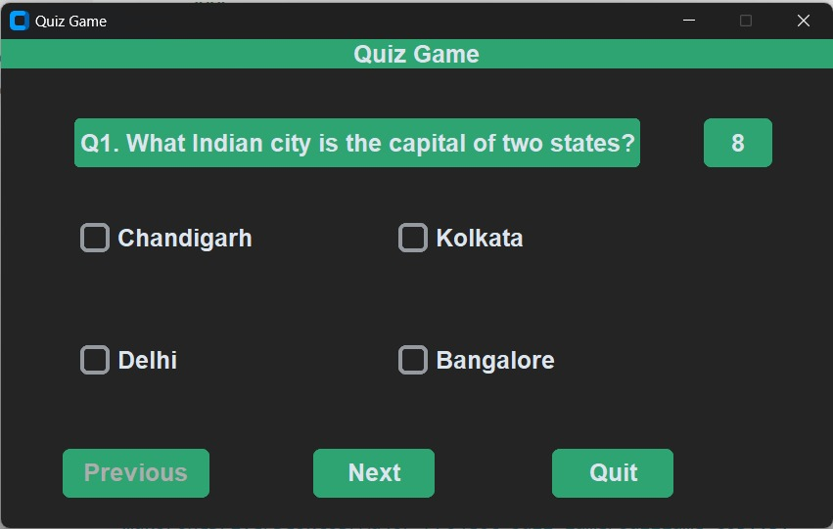

Figure 1

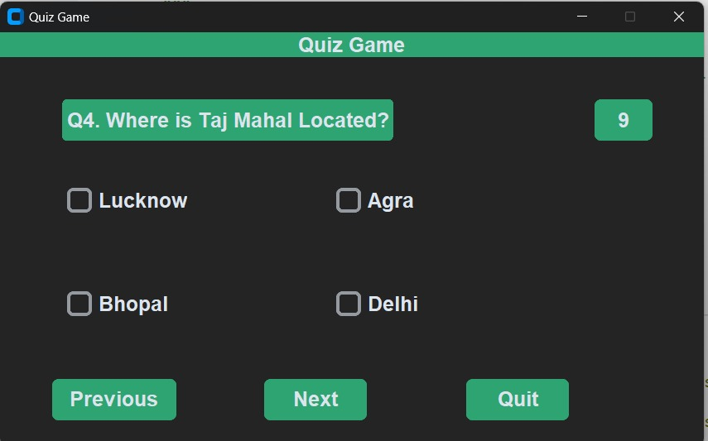

Figure 2

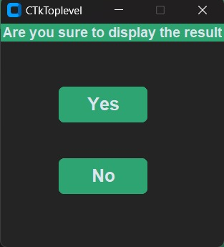

Figure 3

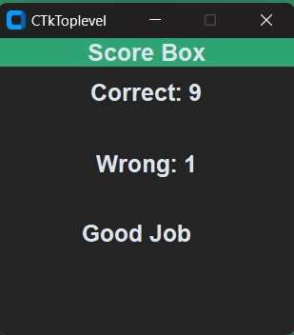

Figure 4

**CONCLUSION**

It was a wonderful experience to work on this project. While working on this project we learn so much about the different ways of learning.

However, we also want to talk about the fact that we think the project fills our objective to make learning fun and interactive at the same time highly knowledgeable

**Future Scope:**

Even the project has an ending. But we think that the "Quiz Game" our project has a big scope in the future. We can expand it in many ways like

* A new challenge mode
* More varieties in questions
* Web implementation